CHG-MERIDIAN shows significant growth for 2019

- Lease origination: 32 percent increase to around €2 billion compared to prior year
- Circular economy: almost 700,000 IT devices refurbished for a second lifecycle
- Coronavirus pandemic: both challenge and opportunity

Weingarten, April 23, 2020

In 2019, the international CHG-MERIDIAN Group was able to continue its favorable business development. The manufacturer and bank independent technology manager increased its volume of lease origination by 32 percent to €1.99 billion (2018: €1.51 billion), exceeding the record figure achieved in 2018. The proportion of international lease origination (outside the home market in Germany) was 60 percent, a rise of 8 percent year-on-year. Profit from ordinary activities (before taxes) amounted to €91 million, which was slightly lower than the prior-year figure (2018: €95 million). The Group’s net income (after taxes) fell by 2 percent to €65 million (2018: €66 million).

“Despite demanding overall conditions such as the downturn of the global economy, serious changes in many industrial sectors, and persistently low interest rates, we were able to continue our success story and set a new record for lease origination of about €2 billion,” says Dr. Mathias Wagner, Chairman of the Board of Management of the CHG-MERIDIAN Group.

In this regard, the international presence in 27 countries represents a key competitive advantage with globally active groups and companies. Both the commercial and technological expertise of CHG-MERIDIAN are in demand on the market: particularly such is especially the case with regard to providing IT infrastructures for the digital workplace and for home-office-settings as well as an efficient lifecycle management for IT digitalization and modernization investments. Alongside IT, healthcare technology for hospitals, warehousing and logistics technology, as well as material handling vehicles for industrial companies are being managed and financed. In 2019, the segments healthcare and industrial technology contributed to 18 percent of the Group’s lease origination.

Refurbishing IT equipment for its second lifecycle

Once more, CHG-MERIDIAN has succeeded in increasing the number of refurbished and remarketed devices. Overall, almost 700,000 IT devices, or 95 percent of all IT hardware and devices returned by customers, could be refurbished and brought onto the secondary market in a second lifecycle.

In addition, professional data erasure remains a vital component of the services offered by CHG-MERIDIAN. Throughout the Group data were certifiably erased from a total of 266,000 assets and devices. This equates to a year-on-year rise of almost 25 percent (2018: 213,000).

“The principles of the circular economy are deeply rooted in the DNA of CHG-MERIDIAN and have shaped our business model for decades. Professional refurbishment of used IT equipment and its subsequent remarketing belong to our core competencies. In doing so, we link our entrepreneurial activities with environmental, social, and community concerns,” says Dr. Wagner.

Coronavirus pandemic: both challenge and opportunity

Currently, the Coronavirus pandemic is having an impact on every company. With the business success from 2019, and with a sustainable, robust business model, as well as a comprehensive crisis management CHG-MERIDIAN has been weathering the associated economics crisis quite well as of today. However, the company assumes the crisis to have a certain negative impact on lease origination in 2020. The dimension would depend on how long the crisis situation continues further.

“We have a positive outlook for the period following the crisis and in the medium term. In recent weeks, many companies have identified deficits in the area of digitalization and remote working or restrictions for home-office settings. In this regard, we can offer targeted support based on our experience and services,” says Dr. Wagner.

Further information can be found at www.chg-meridian.com

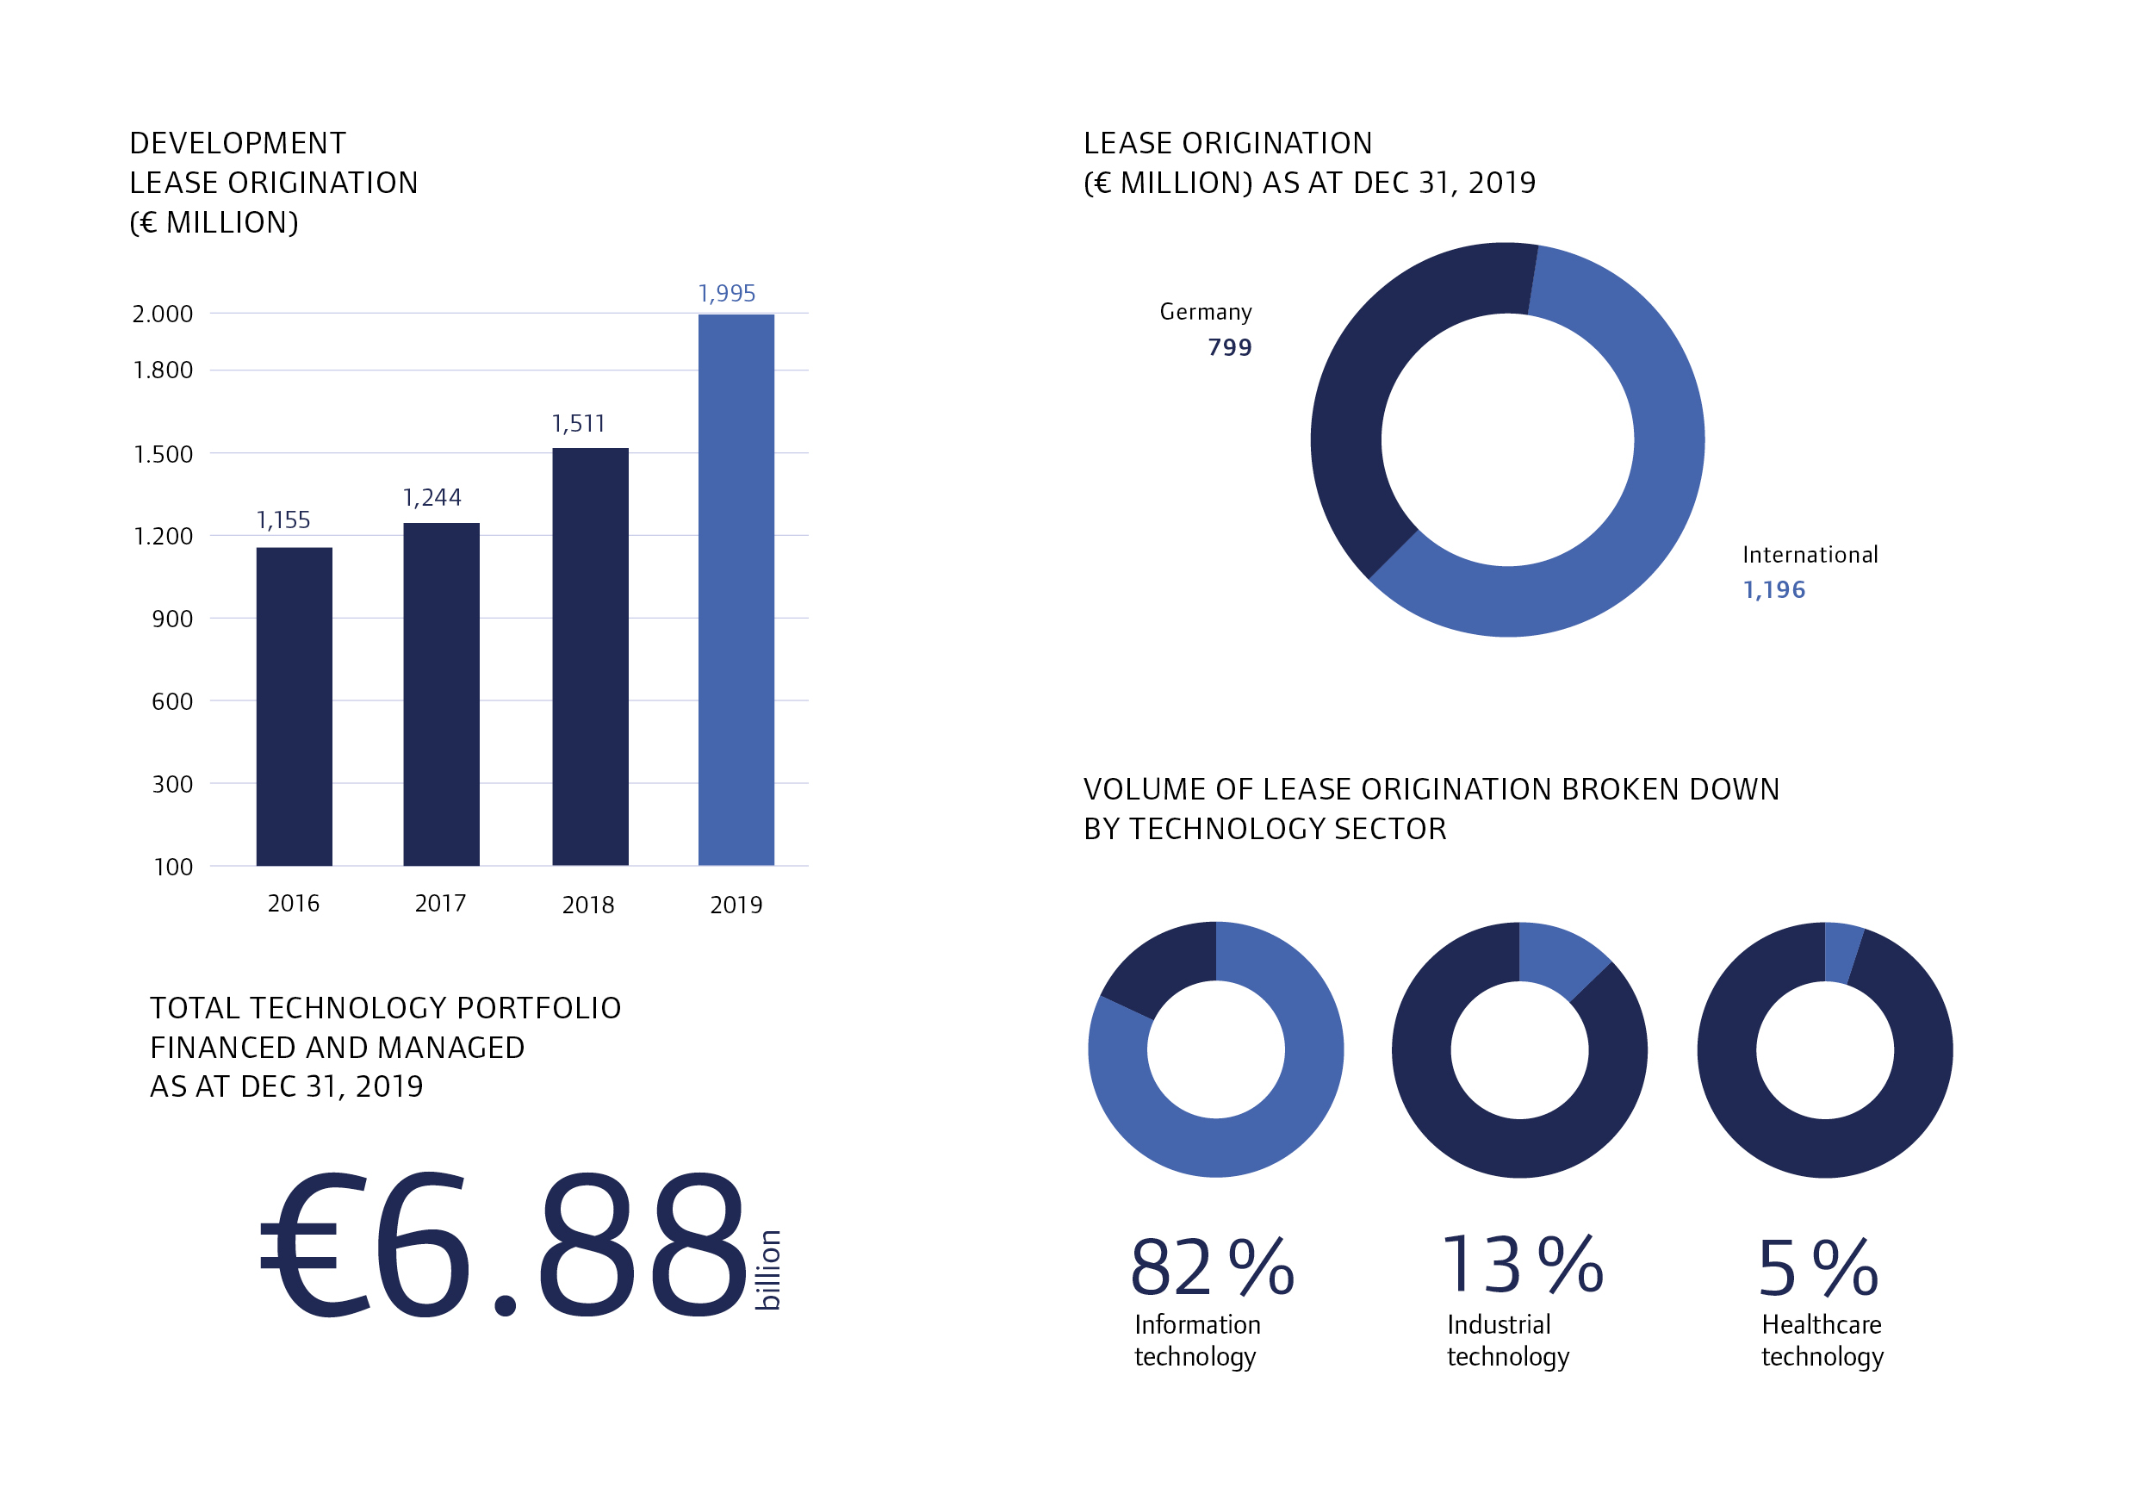

The CHG-MERIDIAN Group

The CHG-MERIDIAN Group is one of the internationally leading manufacturer and bank independent technology managers in the IT, industrial and healthcare technology sectors. 12,000 customers - including corporations, SMEs and the public sector - rely on CHG-MERIDIAN to manage their technology infrastructures in a holistic, user-oriented and digital way. Based on the concept of the circular economy, the service portfolio ranges from planning, operational implementation and financing, through to certified data erasure, refurbishing and remarketing of used equipment at two in-house technology centers in Germany and Norway. The web-based technology and service management system TESMA® combines commercial and technological data to optimize processes and realize cost savings. The Group has an international presence with around 1,100 employees and operates in 27 countries. By the end of 2019, CHG-MERIDIAN financed and managed a total technology portfolio of €6.88 billion. Headquarters is in Weingarten, Germany.

Efficient Technology Management®

